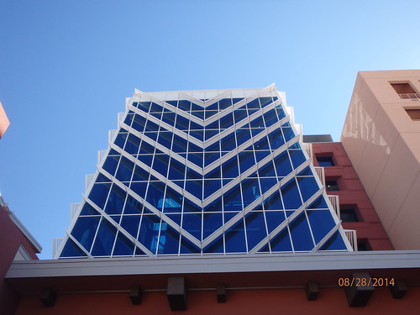
This Photo by Unknown Author is licensed under CC BY

NMHCA/NMCAL
Long-Term Care Expo

Albuquerque
Isleta Resort and Casino
11000 Broadway SE
August 18-19, 2020

nmhca.org

GENERAL INFORMATION

NMHCA is the only professional long-term care trade association in New Mexico. We count in our membership the majority of the
state’s licensed nursing facilities, many assisted living/residential care facilities, and 100% of the intermediate care facilities for individuals with intellectual disabilities (ICF/IIDs). These members spend over $30 million per year on products and services for day-to-day operations and patient/resident care. The NMHCA Convention & Exposition is the single largest gathering of these long-term care professionals in New Mexico.
ATTENDEES: Attendees include healthcare facility owners, directors, administrators, management and nurses. Vendors include companies serving facilities within New Mexico. The member facilities of NMHCA employ more than 6,000 people across the state in areas such as management, nursing, laundry, housekeeping, maintenance, activities, social work and dietary.

EXHIBITOR BENEFITS:
- Conference access for four company representatives
*Additional representatives are $50 each. Representatives may not be from multiple sites of a facility-based organization.
- Complimentary meals served during Exposition hours to include breakfast, lunch and cocktail grand opening.
- Conference attendee list e-mailed post-function* (Microsoft Excel format)
*We can send pre-function, but due to the tendency of attendees to register late, the list is not guaranteed to be complete.
- Increase company awareness
- Promote brand image & visibility

EXHIBIT RATE & CANCELLATION POLICY:
- Member Rate: $600 if paid before May 1, 2021
$675 if paid after May 1, 2021

- Non-Member Rate: $750 if paid before May 1, 2021
$875 if paid after May 1, 2021
Credit card payments are accepted online only through the registration portal.

Exhibit space includes: 8’ draped back wall, 3’ draped side rails,
1 8’ draped table, 2 molded plastic chairs, 1 7” x 44” ID sign, 1 waste basket w/ liner. The exhibit hall IS carpeted.

Refunds minus a $50 administrative fee will be issued if requested in writing by July 1, 2021. NO REFUNDS WILL BE ISSUED AFTER JULY 1, 2021. Exceptions will be made in the event of a sellout.

CANCELLATION BY NMHCA: NMHCA reserves the right to cancel any event due to unforeseen and uncontrollable circumstances, including, but not limited to, weather, natural disasters, acts of God, acts of Terror, union strikes, or other labor stoppages. In the event of such a cancellation, all fees paid to the Association will be refunded. However, NMHCA will not be responsible for other related costs incurred by exhibitors.

PENALTY CLAUSE & INFRACTION POLICY: Any infraction of the New Mexico Health Care Association (NMHCA) rules governing the conference by the exhibiting company and its representatives will result in the exhibiting company not being permitted to participate at future conferences. NMHCA reserves the right to immediately
close any exhibit not in conformance with hotel, fire marshal or NMHCA standards. NMHCA reserves the right to refuse the booth space application for any exhibit, and once the exhibit is on the floor, to require its modification or removal if NMHCA considers such exhibit detrimental to the public or its business, professional or ethical interests, or if its displayed products do not meet the professional standards of NMHCA. NMHCA reserves the right to make these determinations and its decision will be final.
LIABILITY: NMHCA, the host property, show management, employees or representatives of those bodies will not be held liable for injuries to any person or for any loss or damage to property owned or controlled by the exhibitor which claims for damages or injuries may be incident to, arise from, or be in any way connected with the exhibitor’s display. The exhibitor shall indemnify and hold harmless the New Mexico Health Care Association, the management of the Association and the owners and employees of the host property against all such claims. If any legal action is necessary to enforce the terms of this contract, the prevailing party shall be entitled to reasonable attorney’s fees in addition to any other relief to which he/she may be entitled.
Exhibitors desiring to insure their exhibit merchandise and display materials against loss of any kind may do so at their own expense. The Association suggests that such exhibitors contact their own insurance brokers who will secure for them exhibit rider policies which will provide risk insurance covering their property and merchandise while they are absent from their home premises for exhibition purposes. Exhibitors will be responsible for any damage done to the building by them or their employees. Nails, tacks, or screws must not be driven into walls, floors, or woodwork

SHIPPING/STORAGE/LOADING/UNLOADING OF MATERIALS:
All materials should be sent through Convention Services of the Southwest (CSS) or brought with you when the hall opens for setup. Any other arrangements and any costs involved are your responsibility.

EXHIBIT BALLROOM: Exhibitors will set up in the exhibit hall any time after 11:00 am on August 18, 2021.
All vendors must be set up by 4:00 pm on August 18, 2021. All vendors must also provide their own means and labor to pack/unpack/ and load-in/out their displays. The hotel will not provide labor/carts.

DAMAGES AND REPAIRS: Nothing may be posted on, nailed, screwed or otherwise attached to columns, walls, floors or other parts of the Ballroom, the building, or the furniture. All machinery is prohibited. Should heavy soiling of carpeting occur, shampooing or spot removal will be charged to the exhibiting company. Charges for repairs will be determined after consultation with a carpet expert. All property destroyed or damaged by the exhibitor must be replaced in its original condition by the exhibitor or at the exhibitor’s expense

FIRE REGULATIONS: Decorative materials such as curtains, draperies, streamers, fabrics, cotton batting and straw must be noncombustible or flame resistant, complying with the standards set forth by the Fire Marshal. Certificates attesting to the fact that all materials referred to above have been flame proofed in accordance with the regulations must be notarized and submitted upon request.

ELECTRICAL SERVICE: NMHCA does not provide electrical service. You may contract with Convention Services of the Southwest.

HIGH-SPEED WIRELESS INTERNET ACCESS: NMHCA will not provide internet access. Typically, this is done by the AV staff at the hotel and should be paid for at the time you order it.

SECURITY: Exhibitors are advised to carefully review the “hold harmless” agreement under the liability section of the Trade Show Rules, which are part of this exhibit contract. Each company/organization should have applicable theft insurance and must accept risk on its own. Although security cameras are on at all times, exhibitors with sensitive equipment or materials that might be the target of theft are strongly encouraged to take additional precautions. DO NOT leave valuables unattended at any time.

BOOTH PLACEMENT AND USAGE
Requests for exhibit space should be submitted on the enclosed Application. Space assignments are typically made on a first come, first served basis, but priority is given to repeat vendors who register before May 1, 2021. Should NMHCA be unable to place you in the booth you select, we will locate you as closely as possible to your original choice. No two organizations may share the same booth. Organizations choosing not to purchase a booth will not be permitted to display products/services at the trade show. There is no limit, however, on the number of booths you may rent. All reservations made by email or fax must be confirmed by a completed, signed contract and payment in full.

Exhibitors must arrange their exhibits so as not to obstruct the other exhibits. Aisles must be kept clear. To this end, exhibits should be arranged so that booth attendants will be inside the space assigned. NMHCA reserves the right to prohibit any display or exhibit or any part of a proposed exhibit, which it deems unsuitable, or not in accordance with reasonable standards of professionalism. NMHCA reserves the right to deny booth rental to any individual or organization that does not conform to the basic principles and ideals of NMHCA and its members.
NO GUEST POLICY: The exhibiting company is not permitted to invite guests to the conference. All attendees must register for the convention and/or trade show. Trade show passes are available for facility-based staff at a cost of $75. Passes are not available to employees of companies or anyone wishing to solicit business from attendees and are not valid for education

COMPANY PRIZE DRAWINGS: NMHCA sponsors a “traffic builder” to maximize attendance. There are multiple prizes with the grand prize being $300 cash. The drawings will take place in the exhibit hall following lunch on Thursday, August 19, 2021. We invite exhibitors to offer prizes, and should you wish, NMHCA will announce the winners or include them in our drawing, with credit to the vendor, of course. Please bring your prizes to the prize table no later than 1:00 pm and make sure they are clearly marked. NMHCA’s winners must be present in the room. If they are not present, another name will be drawn until there is a winner present.
Sponsorships: NMHCA offers a variety of sponsorships, which provide you the opportunity to maximize your exposure. From general sessions to education to bag stuffers, we have an opportunity that will meet your budgetary needs.

HOTEL RESERVATION PROCEDURE: Registration does not include lodging. All lodging must be made/paid by each participant.
Guest room reservations will be made by individual attendees directly with hotel reservations at (877) 747-5382 or (505) 848-1999. Mention the NMHCA Convention and Exposition or the group code of NMH0821 to receive a discounted rate of $129/night. The cutoff date is July 16, 2021.
Reservations are on a first come, first served basis. Hotel check-in is after 4 p.m. and checkout is by 11 a.m.
HOTEL DIRECTIONS: The directions to Isleta Resort and Casino can be found online on the registration page.

EVENT QUESTIONS?
EXHIBITOR & INDIVIDUAL REGISTRATIONS / PAYMENT / MEMBERSHIP STATUS / GENERAL CONFERENCE QUESTIONS

Tracy Alter, Senior Director of Member Services
505-880-1088 l talter@nmhca.org

Remit Payment to:

New Mexico Health Care Association (NMHCA)
4600A Montgomery Blvd. NE Ste. 205
Albuquerque, NM 87109

or online through the registration page.
valid for education sessions.

CONFERENCE AT-A-GLANCE

 |  |  |  | Thursday, August 19, 2021
 |  |  | 7:30–900 a.m. | Membership Meeting  Breakfast in the Exhibit Hall
 | Wednesday, August 18, 2021 |  | 9:00–10:30 a.m. | Education sessions
8:00 a.m. | Association Meetings |  | 10:45 a.m.–12:15 p.m. | Education sessions m
11:00 a.m. | Exhibitor Setup *Exhibitors with booth numbers 28-55 can’t begin setup until after 2:00 pm |  | 12:15–2:00 p.m. | Complimentary lunch, tour of exhibits,  exhibitor prize drawings
12:00–2:00 p.m. | Grand Opening and Awards Luncheon |  | 2:00–6:00 p.m. | Exhibitor Tear Down – must be out no later than 6:00 p.m.
2:00–3:30 p.m. | Education sessions |  | 2:00–3:30 p.m. | Education sessions
3:30–4:00 p.m. | Refreshment Break |  | 3:00–3:15 p.m. | Refreshment break
4:00–4:30 p.m. | Exhibitor Informational Meeting |  | 3:15–5:15 p.m. | Education sessions
4:00–5:15 p.m. | Education sessions |  |  | Friday, August 20, 2021
 |  |  | 8 – 9 a.m. | Complimentary breakfast Cappriccio Restaurant
5:30 p.m. | Grand Opening in the Exhibit Hall  Cocktails and Appetizers |  | 8:00–8:30 a.m. | Refreshment Break
 |  |  | 8:30–10:00 a.m. | Education Sessions
 |  |  | 10:15–11:45 a.m. | Education Sessions

Exhibit Hall

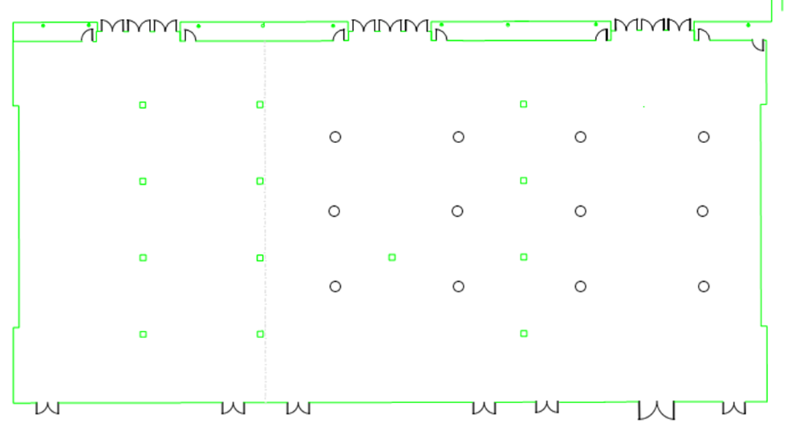

55 |  | 42 | 41 |  | 28 | 27 |  | 15 | 14 |  | 1
54 |  | 43 | 40 |  | 29 | 26 |  | 16 | 13 |  | 2
53 |  | 44 | 39 |  | 30 | 25 |  | 17 | 12 |  | 3
52 |  |  |  |  |  |  |  |  |  |  | 4
51 |  | 46 | 37 |  | 32 | 24 |  | 19 | 10 |  | 5
50 |  | 47 | 36 |  | 33 | 23 |  | 20 | 9 |  | 6
49 |  | 48 | 35 |  | 34 | 22 |  | 21 | 8 |  | 7

Exhibit Hall
Main Entrance
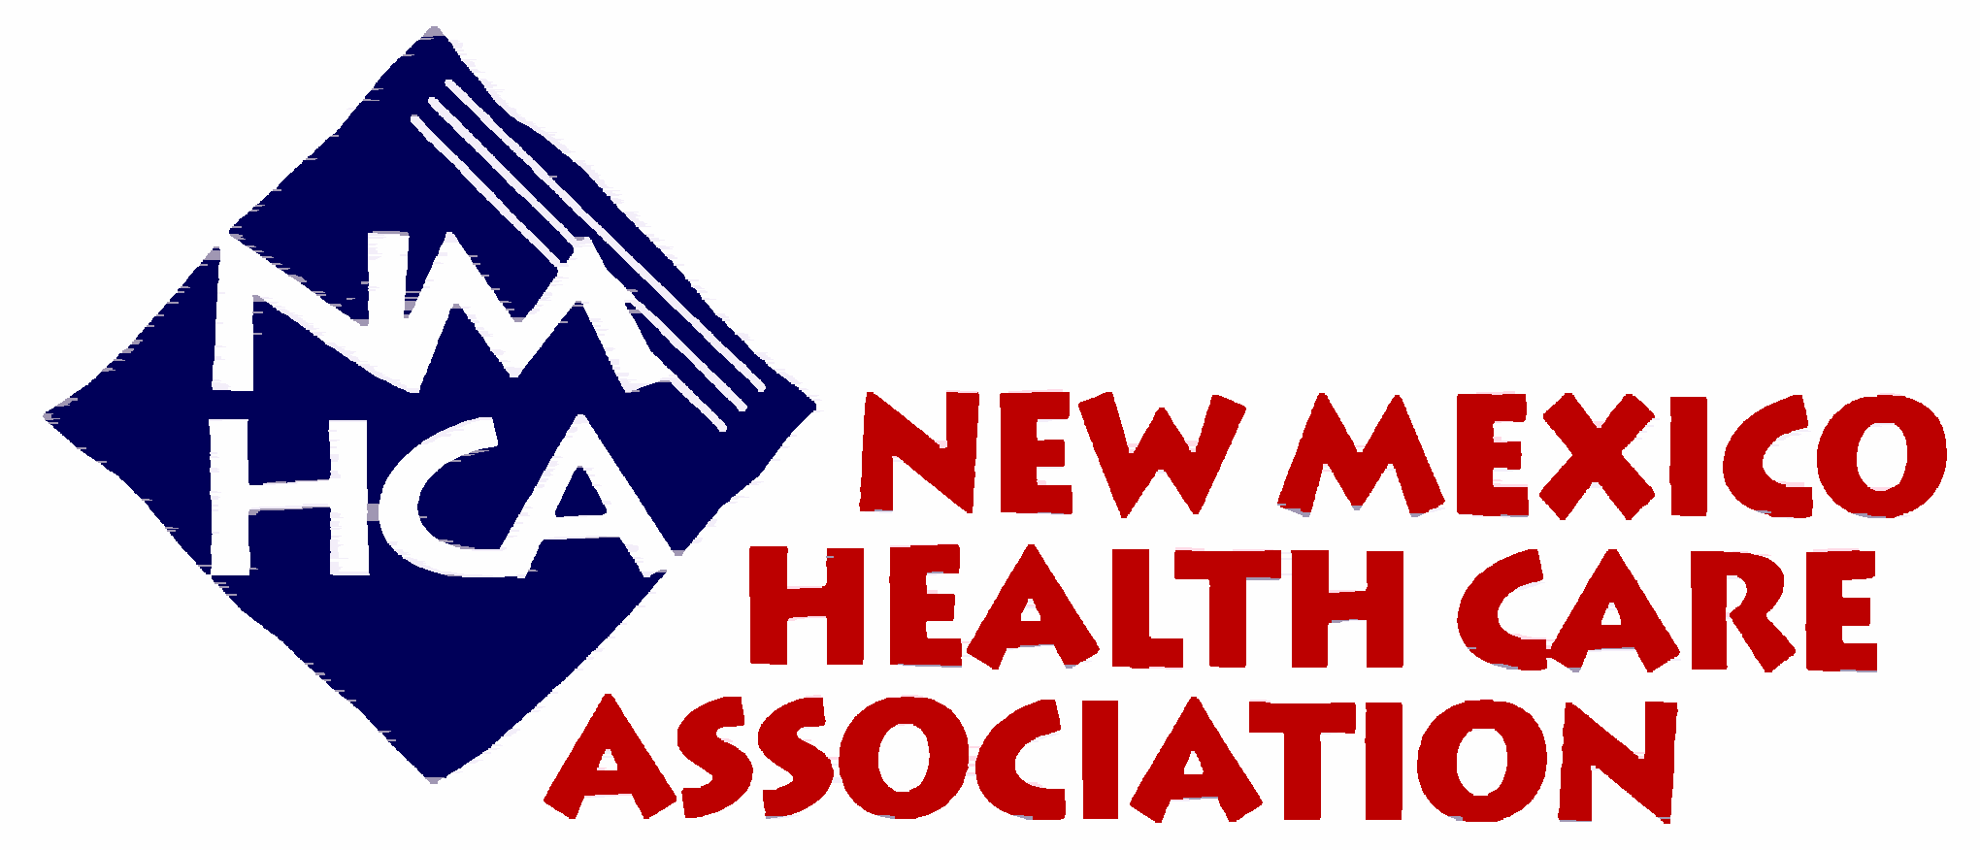

2021 Convention & Exposition

BOOTH CONTRACT

Each exhibitor must have a completed and signed Booth Contract on file in the NMHCA office accompanied by payment in full NO LATER than July 30, 2021. NMHCA reserves the right to release for sale any booth not paid in full by May 1, 2020. Booths not paid in full by May 1, 2021, will be billed at the regular rate. A copy of the contract will be returned to you upon receipt of payment in full. Please type or print clearly!

Company Name:
(Please print exactly how it should appear in the Convention & Exposition Guide and on the booth signage)
Billing Address:
City: State: Zip:
Corporate Phone: Fax: ____
Email:
Booth Preference (see floor plan): 1st Choice 2nd Choice 3rd Choice

Booth assignments and confirmation will be made upon receipt of application and booth deposit OR payment in full.

Please indicate if there are companies you wish NOT to be placed next to:

Contact Person (Name & Title):
(Please print exactly how it should appear in the Convention & Exposition Guide)
Contact Person’s Address:
City: State: Zip:
Phone: Fax:
Email:
Service/Product to be displayed:

My signature signifies my agreement to adhere to ALL stipulations included in the “Exposition Rules & Regulations” located in the Exhibitor Prospectus.

Company Representative Date Tracy M. Alter for NMHCA Date

For NMHCA Use ONLY:

Booth assignment(s): Date:

Total Amount Due: $_______________________ Amount Received: $________________________

Balance Due: $____________________ Date Invoiced: ________________ Balance Due by: _______________

Payment in full Received on: _____________________

EXHIBITOR NAME BADGE INFORMATION FORM

In order to ensure a quick exhibitor check in, please complete the information below and return this form to NMHCA as soon as possible. Additions and/or changes to attendees should be submitted no later than Friday, July 28, 2021, to ensure your attendee badges are complete.

Company:

Name 1:
Title:

Name 2:
Title:

Name 3:
Title:

Name 4:
Title:

Thank you for your collaboration!

If you have any questions, please contact Tracy Alter at 505.880.1088 or by email at talter@nmhca.org.

Additional badges are available at $75 each to cover the additional costs incurred. This does not include education sessions.

