NMHCA Forum Access

All non-member facilities must complete a temporary membership application to gain access to the forum. The application can be found under the Join Today! link on www.nmhca.org. There is no charge for this and the membership will expire after 30 days with a renewal option based on the status of COVID-19 in New Mexico.
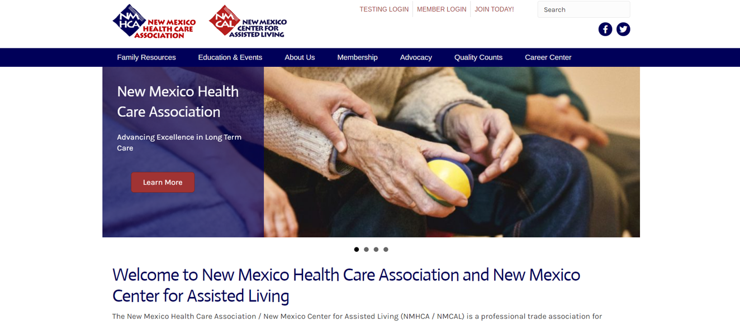

To set up your account, simply click on member login at the top of the page. At the bottom of the log in screen, you will see Create an Account. Fill out your name and facility email and click submit. If you are in the system, it will then allow you to create a password. The system generates your user name in the first dot last format.

Logging in will take you to the connection and resource center. On the left side, you will see the menu. Click on Forum and the list of rooms will pop up on the right side. Click on PPE Sharing and you will be able to begin discussing PPE. Suggested topics include reputable vendors and availability and group purchasing to help maximize your buying power.

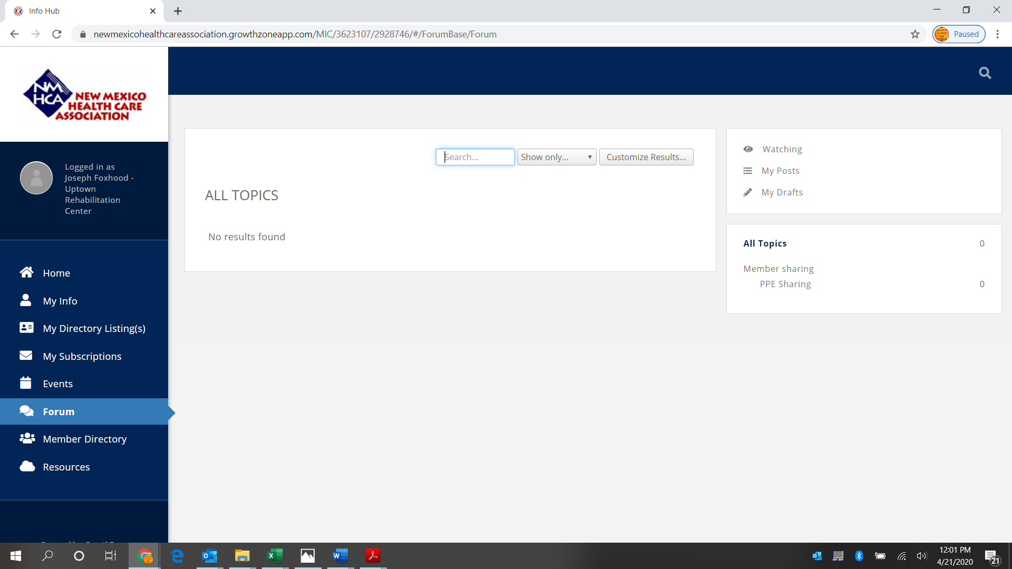

Any questions regarding this should be emailed to nmhca@nmhca.org.

